**GUIDE**

1. **Install Anaconda and Visual Studio Code**

Install anaconda on your OS by following instruction in following link

<https://docs.anaconda.com/anaconda/install/index.html>

Download visual studio code and install it from following link

<https://code.visualstudio.com/>

1. **Setup Environment**

Create env name project_tf using following command

* conda create -n python=3.8

Install tensorflow

* pip install tensorflow

Install OpenCV

* pip install opencv-python

Install matplotlib

* pip install matplotlib

Install tensorflowjs to convert model from keras to js format

* Pip install tensorflowjs

1. **Run Code**

Download dataset from the following link

<https://www.kaggle.com/datasets/emmarex/plantdisease>

Extract data into directory where code files are present as shown in figure

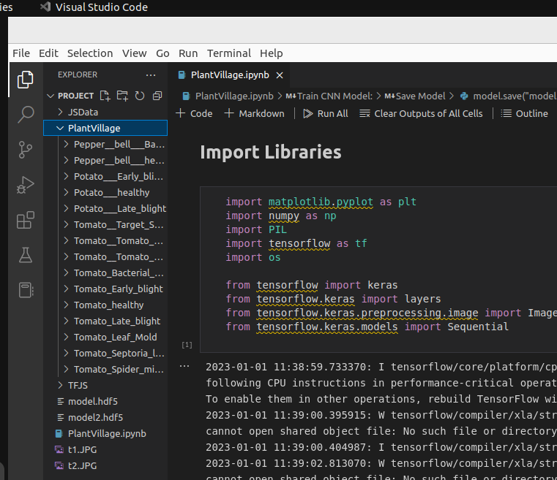

Run PlantVillage File to train Model and save model into model.hdf5 file

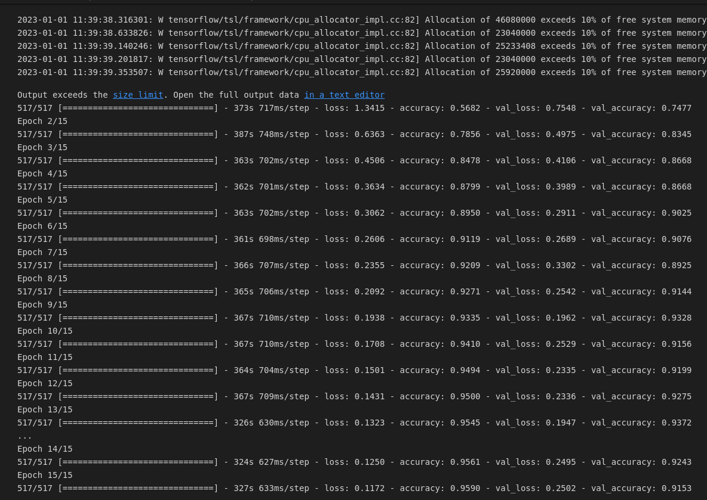

Convert keras model to js required format using following command and place resulted files inside folder used by

* tensorflowjs_converter --input_format keras --output_format=tfjs_graph_model model.hdf5 TFJS/

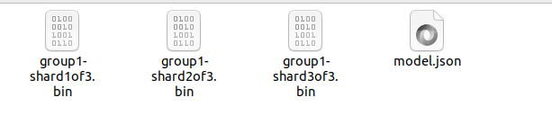

1. **Setup Server**

Install Live Server Extension inside Visual Studio code as shown in below figure

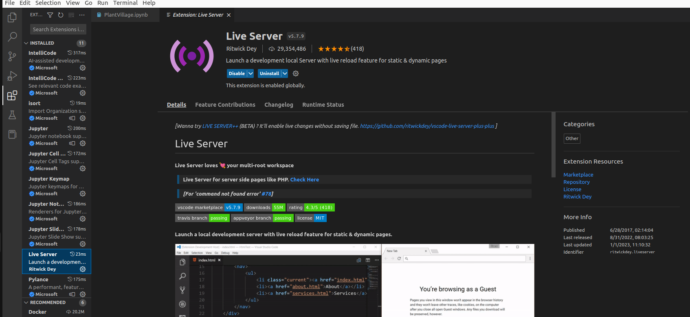

1. **Test App**

Go to index.html file and click on Go live in bottom right corner

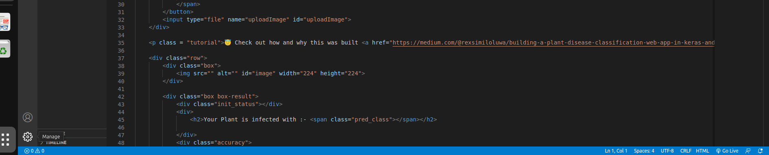

Go to <http://127.0.0.1:5500/index.html> and test application

